ADDITIONAL QUESTIONS:
1]
#include<stdio.h>
void countingSort(int a[], int n){
int max = a[0];
for (int i = 1; i < n; i++)
if (a[i] > max) max = a[i];
int count[100] = {0};
for (int i = 0; i < n; i++)
count[a[i]]++;
int index = 0;
for (int i = 0; i <= max; i++)
while (count[i]--)
a[index++] = i;
}
int main(){
int a[100], n;
printf("Enter n: ");
scanf("%d", &n);
printf("Enter elements: ");
for (int i = 0; i < n; i++) scanf("%d", &a[i]);
countingSort(a, n);
printf("Sorted array: ");
for (int i = 0; i < n; i++) printf("%d ", a[i]);
}
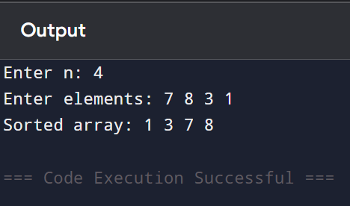
2]
#include<stdio.h>
int getMax(int a[], int n){
int m = a[0];
for (int i = 1; i < n; i++)
if (a[i] > m) m = a[i];
return m;
}
void countSort(int a[], int n, int exp){
int output[100], count[10] = {0};
for (int i = 0; i < n; i++)
count[(a[i] / exp) % 10]++;
for (int i = 1; i < 10; i++)
count[i] += count[i - 1];
for (int i = n - 1; i >= 0; i--){
int digit = (a[i] / exp) % 10;
output[count[digit] - 1] = a[i];
count[digit]--;
}
for (int i = 0; i < n; i++)
a[i] = output[i];
}
void radixSort(int a[], int n){
int max = getMax(a, n);
for (int exp = 1; max / exp > 0; exp *= 10)
countSort(a, n, exp);
}
int main(){
int a[100], n;
printf("Enter n: ");
scanf("%d", &n);
printf("Enter elements: ");
for (int i = 0; i < n; i++) scanf("%d", &a[i]);
radixSort(a, n);
printf("Sorted array: ");
for (int i = 0; i < n; i++) printf("%d ", a[i]);
return 0;
}
